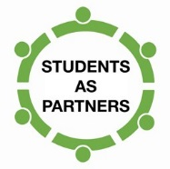**Case Study: [org unit]**

**Title of Case Study** (*<20words*)

Describe case study here – guiding questions provided (*<300words*)

*What are the aims/goals of your ‘Students as Partners’ initiative?*

*How does your ‘Students as Partners’ initiative practically work?*



**Name**

**Email**

**Phone**

**University**

**Website**

**Updated**

**[Students as Partners](http://itali.uq.edu.au/matthews-studentsaspartners)**

**[Kelly Matthews National Teaching Fellowship](http://itali.uq.edu.au/matthews-studentsaspartners)**